Fine Viennese Stadlmann Violoncello

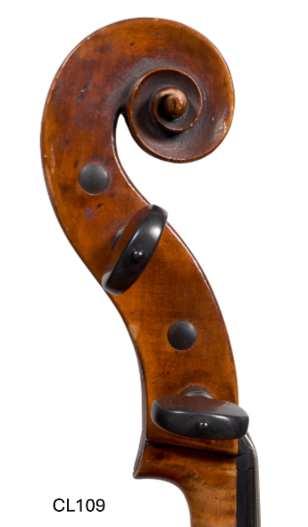
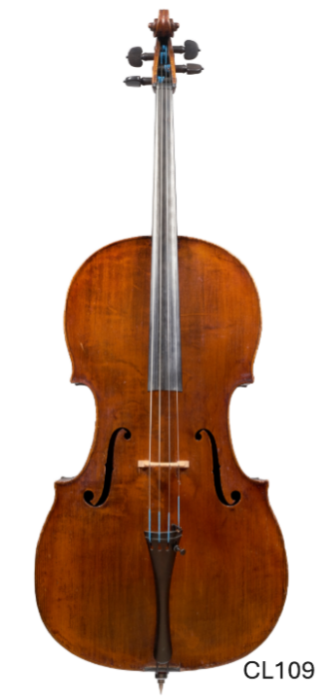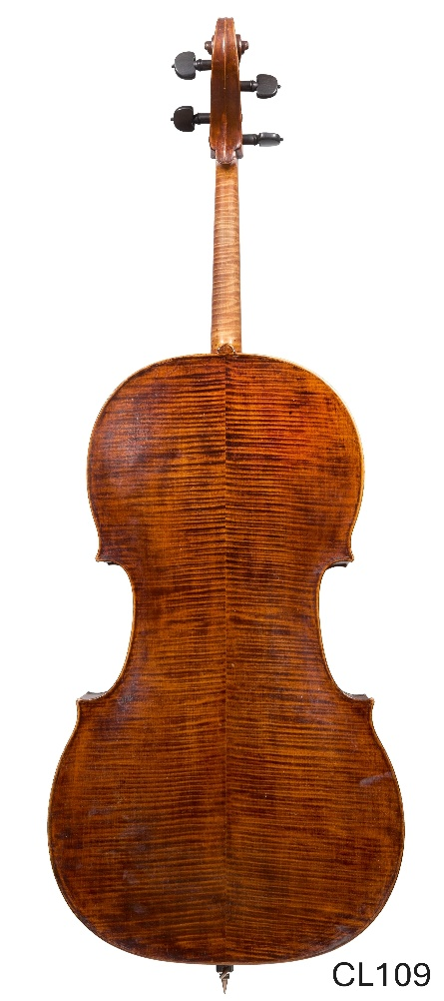This exceptional Stadlmann violoncello represents the height of the classical Viennese tradition and stands as a remarkably preserved example of one of Vienna’s most distinguished families of makers. Elegant, refined, and visually arresting, the instrument embodies the cultivated artistry and noble proportions associated with the greatest eighteenth-century Viennese craftsmanship.
Built on a graceful and beautifully balanced classical model, the cello possesses supple arching, exquisitely worked edges, and a confident architectural harmony throughout. The scroll is boldly yet sensitively carved, revealing both strength and sophistication, while the beautifully proportioned sound holes lend the instrument an unmistakably aristocratic character. The varnish, a rich red golden amber laid over attractive and carefully selected Tonewood, possesses exceptional transparency and depth, creating a luminous visual presence under stage lighting.
What is especially remarkable is the condition of the instrument. Preserved in near-mint state, the cello retains an extraordinary freshness rarely encountered in instruments of this pedigree and period. The surfaces remain vibrant and alive, allowing the refinement of the workmanship and the beauty of the materials to be appreciated in unusually pure form. Fine Viennese master cellos of this quality and preservation have become increasingly difficult to locate, particularly examples retaining such freshness while also offering concert-level tonal performance, making this instrument not only artistically compelling but highly desirable from both a collector’s and investment perspective.

Tonally, the instrument is every bit the equal of its visual beauty. Recently fitted with a new bass bar, the cello has opened magnificently, producing a voice of warmth, breadth, and striking immediacy. The lower register is powerful and resonant without heaviness; the middle register possesses a richly lyrical and human quality; and the upper register projects with focus, clarity, and singing brilliance. Response throughout the instrument is exceptionally even and satisfying beneath the bow, making the cello equally compelling for solo literature, chamber music, and orchestral performance.

There is a cultivated nobility to the sound that one associates with the finest Viennese instruments, refined yet deeply expressive, elegant yet commanding. The cello does not merely look beautiful; it sounds beautiful in the fullest artistic sense, combining tonal richness with sophistication and ease of response.

The Stadlmann family occupies an important and foundational place in the history of Viennese violin making. Many historians regard them among the earliest great masters who helped establish the character and identity of what became the celebrated Viennese school. Their instruments have long been admired for their refined workmanship, elegant outlines, and warm, noble tonal qualities. This particular cello was acquired through a respected London violin shop and was greatly admired by the noted New York expert Christoph Landon, further reinforcing the instrument’s distinguished provenance and artistic significance. A rare opportunity to acquire an historically important and musically compelling Viennese master cello of exceptional preservation, beauty, and tonal distinction.

Inquiry@Bergonziviolins.com

